Martinis $12

Pomegranate
vodka, pomegranate liqueur, Cointreau and sweet-n-sour.

Wedding Cake
vanilla vodka, amaretto and pineapple juice

Lemon Drop
lemon vodka, triple sec, sweet-n-sour and simple syrup

Ronnie Barnes
vanilla vodka, mozart white chocolate liqueur,
dark crème de cacao and half-n-half

White Chocolate Strawberry
Vanilla vodka, mozart white
chocolate liqueur, strawberry puree and half-n-half

Key Lime
key lime rum, white rum, pineapple and lime juice

Bay Breeze
vodka, coconut rum, blue curacao and pineapple juice

Lemon Blueberry
blueberry vodka, lemon vodka, cointreau and sweet-n-sour

Cosmopolitan
vodka, triple sec, cranberry and lime juice

Lemon Twist
lemon vodka and dry vermouth

Espresso
vanilla vodka, mutiny coffee vodka, simple syrup
coffee concentrate

Melon Martini
cointreau, midori, vodka, sweet-n-sour

Margaritas
Top Shelf Margarita $12
espolon tequila, cointreau, sweet-n-sour
and orange squeeze

Spicy Margarita $8
tequila, triple sec, sweet-n-sour and orange
and lime squeeze

Signature Cocktails

Apple Envy $8
crown apple bourbon and ginger beer

Crooked Captain $12
spiced rum, amaretto, peach schnapps,
cranberry and orange juice

Twisted Arnold Palmer $10
lemon vodka, black tea, simple syrup,
lemon juice

Papa Smurf $8
coconut rum, blue curacao, sprite
and sweet-n-sour

The Joker $10
southern comfort, amaretto, blue
curacao and cranberry juice

Water Moccasin $10
crown royal, peach schnapps, cointreau
and sweet-n-sour

Long Island Iced Tea $12
vodka, gin, rum, tequila, triple sec,
coke and sweet-n-sour

Moscow Mule $12
vodka, ginger beer and lime juice

Blackberry Lemonade $10
blackberry whiskey and lemonade

Planter’s Punch $10
dark rum, orange juice, pineapple juice
lemon and lime squeeze

Dark & Stormy $12
dark rum, ginger beer and lime squeeze

Old Fashion $12
bourbon, simple syrup, club soda,
muddle orange slice, bitters and cherries

Italian Old Fashion $14
Bourbon, aperol, muddle orange slice,
Cocktail cherry and bitters

Cocktail Menu

“Where Fun Meets Elegance”

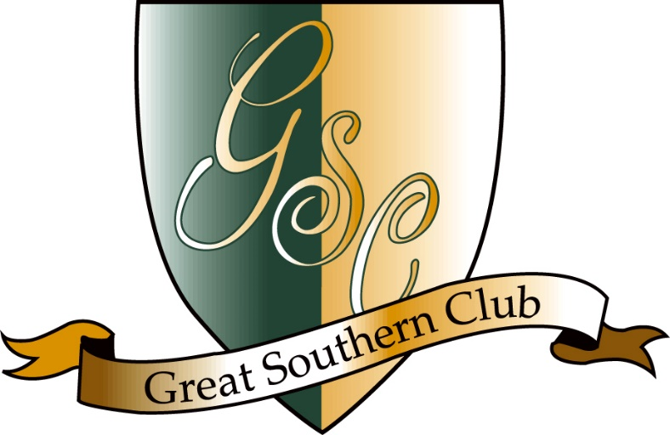

Champagne Cocktails

Poinsettia $9
house champagne and cranberry juice

Mimosa $9
house champagne and orange juice

French 75 $12
champagne, gin, simple syrup and lemon juice

Kir Royale $12
champagne and crème de cassis

Vintage Cocktails $12

Rusty Nail
chivas and drambuie

Negroni
tanqueray, campari, sweet vermouth and orange squeeze.

Sazerac
rye whiskey, pernod, simple syrup and bitters

Tom Collins
bombay gin, sweet-n-sour and lime

Brandy Alexander
remy martin, crème de cacao and half-n-half

Domestic Beer $4

Budweiser
Bud Light
Miller Lite
Coors Lite
Michelob Ultra
Yuengling Lager
Blue Moon
Abita Amber
Sam Adams Boston Lager
Southern Pecan

Import Beer $5

New Castle
Corona Extra
Heineken
Heineken Double Zero
Modelo
Stella Artois

